Dr.-Ing. Bernhard Sagmeister
Datum: 11. Juni 2019
Seite: 1
Press Release
durcrete GmbH
Nanodur UHPC now even more economical and easier to handle thanks to Nanodur Extract

New innovative additive simplifies production of machine beds made from cement-bonded mineral castings

With its Nanodur Extract, Dyckerhoff GmbH has just developed a new additive which will simplify the production of massive machine components, particularly in non-European countries. Nanodur Extract can be mixed on the producer’s premises with local cements and aggregate, as a result of which the production of modern Ultra High Performance Concrete (UHPC for short) becomes even more simple and economical. durcrete GmbH –the specialist for cement-bonded mineral casting in mechanical engineering– will be presenting the new user-friendly system at EMO 2019 in Hanover this coming September.

Massive machine beds made from cement-bonded concrete have been proving their worth on the market for more than one decade. They are used in connection with machine tools, and increasingly also with test benches and automated solutions. In Germany there are several plants producing machine beds of this kind.

Nanodur Extract as an economical alternative for export

The leading binding agent on the market for the Ultra High Performance Concretes used in mechanical engineering applications is Nanodur Compound 5941, made by Dyckerhoff, Germany. In view of its ease of use, the material has been popular for some time in other European countries as well as in China. When it was a matter of export, however, in the past for every 1,000 litres of liquid concrete more than a metric ton of binder needed to be purchased in Germany and shipped to the production site. With its new Nanodur Extract, Dyckerhoff has developed a concentrate which offers significant economic benefits. Just 230 kg of Nanodur Extract are sufficient for 1 cubic metre of concrete; for the rest, locally obtainable, top-quality cements and fine sands can be used. This significantly reduces transport costs and the need of warehousing resources, and at the same time offers the producer cost benefits through the use of locally supplied aggregates, sands and cements. This advantage makes it very much easier to set up new production plants for machine components made from UHPC, and offers investors an easy entry to the production of massive machine beds made from cement-bonded mineral castings.

Technical freedom supports recipe optimization

The technical parameters for the use of Nanodur Extract are practically the same as those of the original mixture. The concrete is still self-compacting and yields a perfect surface. It supports the production both of the standard E45 concrete and of special concrete E80 with a Young´s modulus of 80,000 MPa. With a view to the purposeful adaptation of one formula to locally available raw materials, the Dyckerhoff company is happy to provide the required expertise and laboratory resources. Nanodur Extract offers producers additional options for the ongoing optimisation and adaptation of their recipes. Thus, they can develop on their own ideas that may be less ambitious, with a view to meet the need for more economical products.

durcrete GmbH as partner and consultant

When introducing the new technology, moreover, producers can count on support from durcrete GmbH. Located in Germany, the engineering office specializes in all matters having to do with cement-bonded mineral casting in mechanical engineering, and is willing to help producers if they have any questions. The help they offer is not just restricted to recipes, it also includes plant planning and support with tendering and contracting in connection with mixers, moulds and other kinds of auxiliary equipment. durcrete GmbH has wide-ranging expertise in the design and calculation of massive machine components, and also distributes ready-coated and precision-engineered machine beds.

Modern Ultra High Performance Concrete in mechanical engineering

In the past machine beds were generally made of steel, cast steel or grey cast iron. As a result of technological and economic demands on machine tools, not only machine beds made of cast iron, but also structural components based on materials like mineral casting or epoxy-resin-bonded polymer concrete have become established over the last 30 years. Steel and cast iron are the most stress-resistant of materials, but they take a lot of energy and are expensive to produce. So massive materials like polymer concrete and natural stone are widely used, in view of their lower price or technological benefits. Modern Ultra High Performance Concrete UHPC has now won an established place in mechanical engineering. As well as being economical to produce, concrete offers advantages in connection with both vibration damping and the thermal properties of machine tools, and is coming to replace conventional materials. This innovative high-tech material has given entirely new impulses to modern mechanical engineering. For some years now, a number of prefabricated parts factories all over the world have been successfully producing machine components from Nanodur UHPC.

Hall 7, Stand A83

If you have any questions, please contact:

Dr. Bernhard Sagmeister
durcrete GmbH,
Am Renngraben 7,
65549 Limburg an der Lahn,
GERMANY
Tel.: +49 6431 5840376
e-mail: sagmeister@durcrete.de

Logo of durcrete

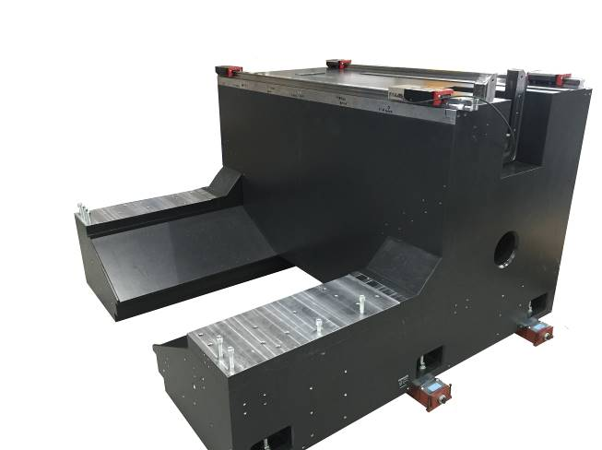

Fig. 1: Vertical milling machine made from Nanodur UHPC, produced in China

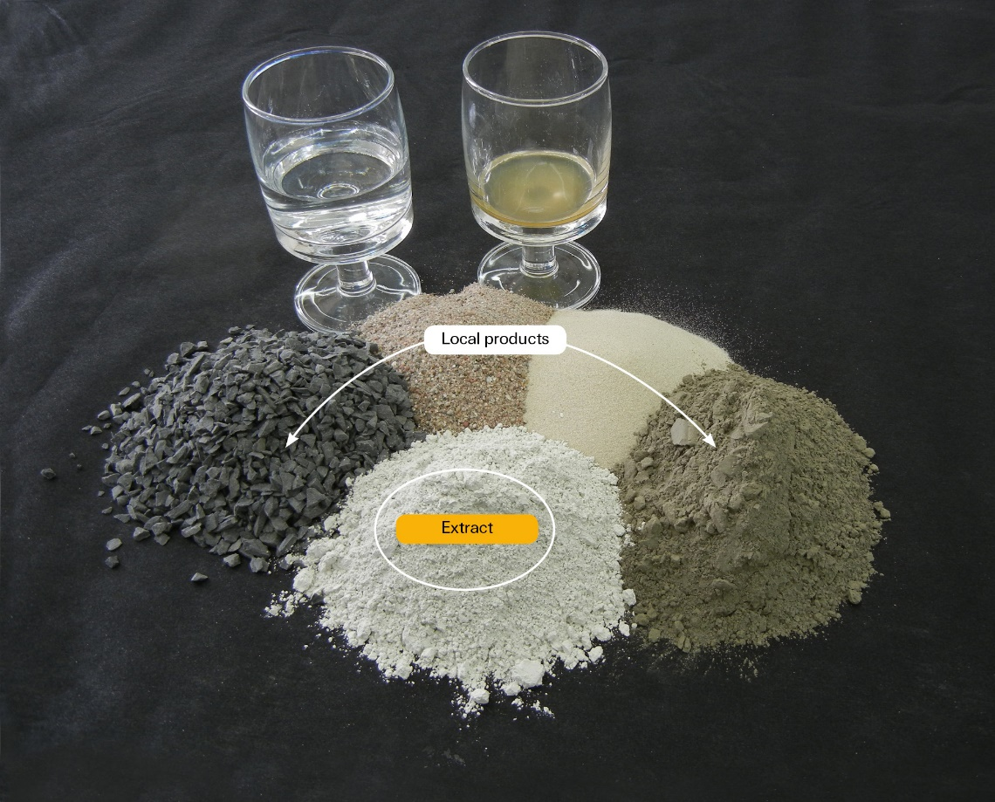

Fig. 2: Constituents of UHPC with Nanodur Extract

